1. Fetch date and temperature from temperature_data where zip code is greater than

300000 and less than 399999.

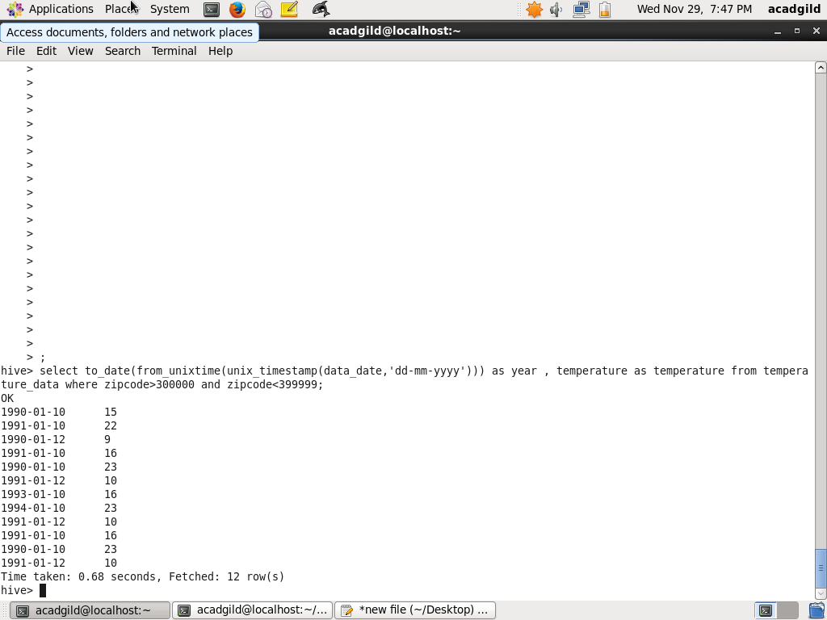

2. Calculate maximum temperature corresponding to every year from temperature_data

table.

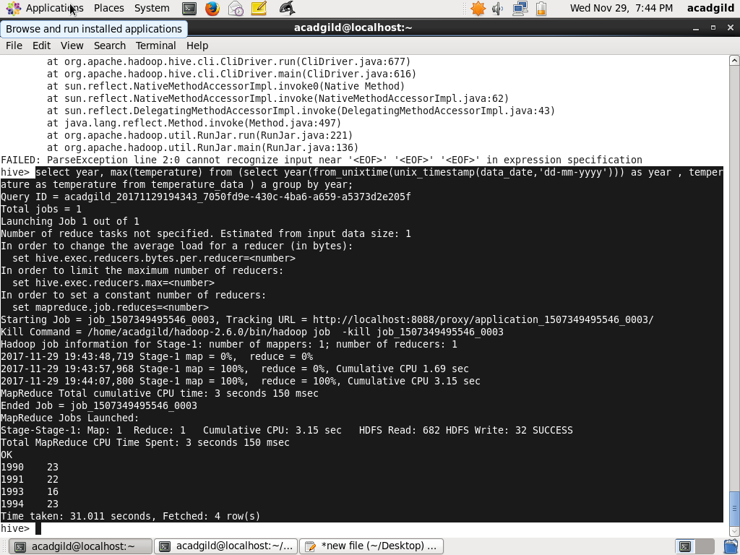

3. Calculate maximum temperature from temperature_data table corresponding to those

years which have at least 2 entries in the table.

Hql:

select a.* from (select year, max(temperature) as temperature from (select year(from_unixtime(unix_timestamp(data_date,'dd-mm-yyyy'))) as year , temperature from temperature_data) a group by year) a join

(select year, count(*) as count from (select year(from_unixtime(unix_timestamp(data_date,'dd-mm-yyyy'))) as year from temperature_data) a group by year having count>1) b where a.year=b.year

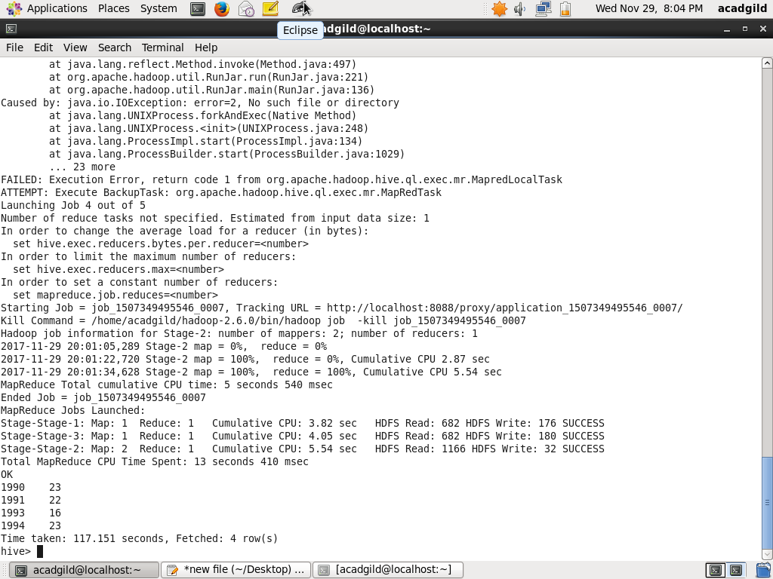

4. Create a view on the top of last query, name it temperature_data_vw.

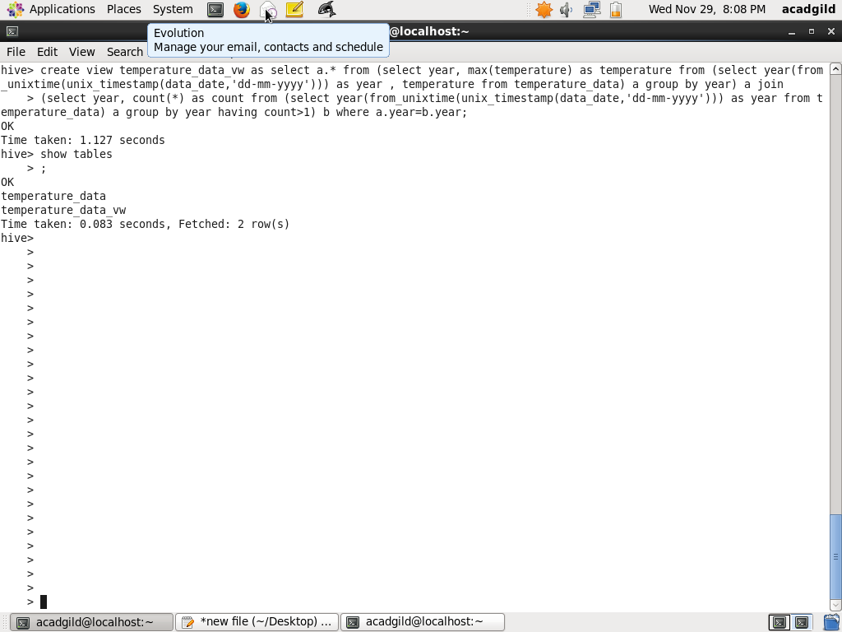

5. Export contents from temperature_data_vw to a file in local file system, such that each

file is '|' delimited.

Hql:

insert overwrite local directory '/home/acadgild/Desktop/out.txt' row format delimited fields terminated by '|' select * from temperature_data_vw;

1990|23

1991|22

1993|16

1994|23

